**USERS**

* **TO START, GO TO  
  1.) Menu  
  2.) Maintenance  
  3.) Users**

Menu

Maintenance

Users

2 1*1*

33 1*1*

1 1*1*

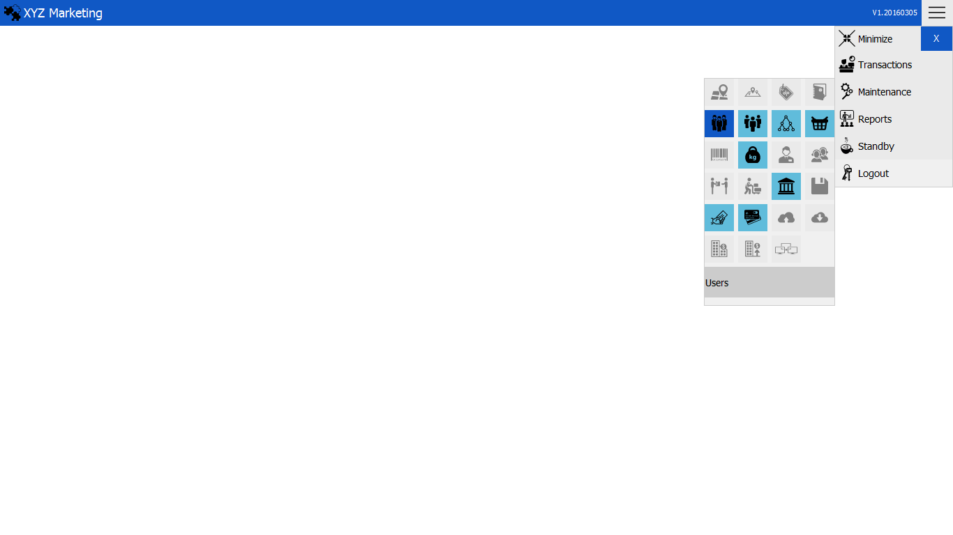

**NEW USER  
1. ) Select branch & location  
2. ) Input users screen name  
3. ) Input users user name  
4. ) Input users password  
5. ) Check users status  
6. ) Add   
7. ) Add previleges**

Users

screen name

Branch & location

2 1*1*

1 1*1*

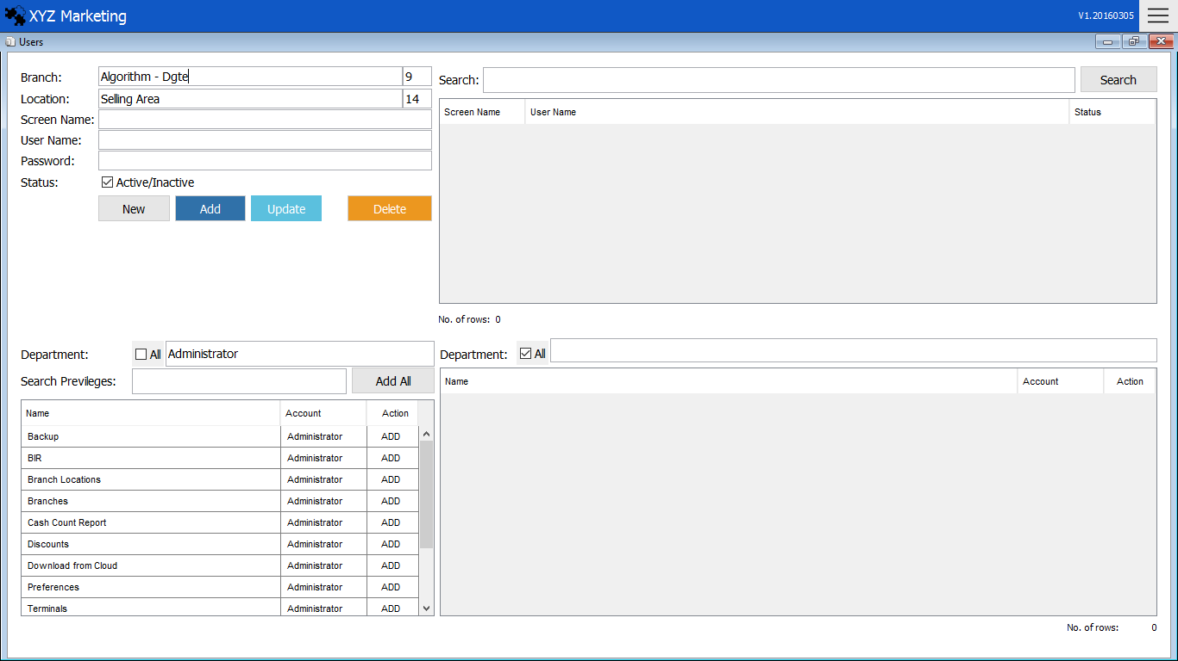

Add Previleges

Add

Users

Status

Users

Password

Users

user name

7 1*1*

6 1*1*

3 1*1*

5 1*1*

4 1*1*

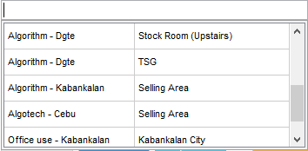 **1. ) Select branch & location**

Choose the branch and location of the user displayed upon opening the input box.

** 2. ) Input users screen name**

Input users screen name or name.

**3. ) Input users user name**

Input users user name or users ID to login.

**4. ) Input users password**

Input users password or access code to login.

  
 **5. ) Check users status**

Check users status  
a.) active  
b.) inactive

**6. ) Add, Update & delete**

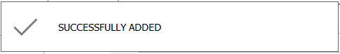**6.1 ) Add**

A message will appear after the users account is added.

After filling all the details click the button add to continue.

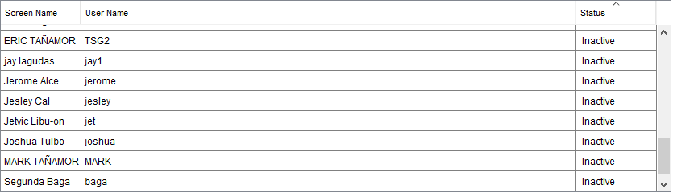**6. 2) Update**



After updating the users account click update button to continue.

Just click the users account in the table.

**6. 3) Delete**

Just click the users account in the table and click delete button to continue.



**7.) Add previleges**

Click the user account in the table.

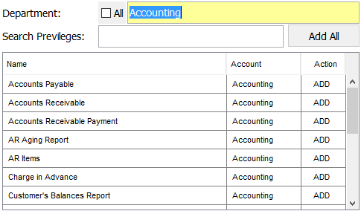

Search

2 1*1*

1 1*1*

List of previleges to add in the users account.

Add

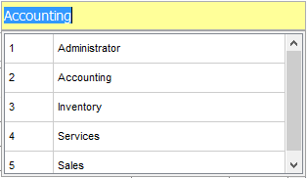**7.1) Search previleges**



You can also search the privilege you want to add to the users account.

You can search previleges by department.

**7.2) Add previleges**



After choosing the users previlege. Click the add button to finish.

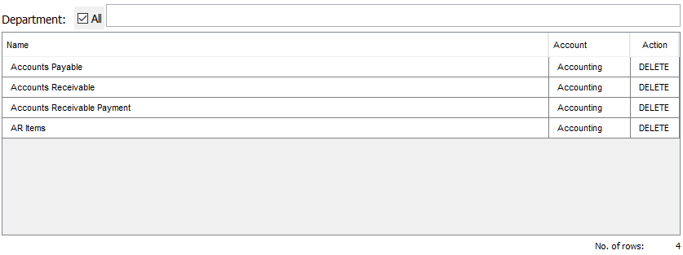

delete

You can see the users previleges in the table displayed in the right side bottom.  
You can also delete previleges by clicking the delete button in the table.